BRANCH TABLE
create table BRANCH (BNAME VARCHAR(20) PRIMARY KEY,CITY VARCHAR(30) CHECK (CITY IN('NAGPUR','DELHI','BANGALORE','BOMBAY')) NOT NULL);

INSERT INTO BRANCH (BNAME,CITY) VALUES ('VRCE','NAGPUR');
INSERT INTO BRANCH (BNAME,CITY) VALUES ('AJNI','NAGPUR');
INSERT INTO BRANCH (BNAME,CITY) VALUES ('KAROLBAGH','DELHI');
INSERT INTO BRANCH (BNAME,CITY) VALUES ('CHANDNI','DELHI');
INSERT INTO BRANCH (BNAME,CITY) VALUES ('DHARAMPETH','NAGPUR');
INSERT INTO BRANCH (BNAME,CITY) VALUES ('MG-ROAD','BANGALORE');
INSERT INTO BRANCH (BNAME,CITY) VALUES ('ANDHERI','BOMBAY');
INSERT INTO BRANCH (BNAME,CITY) VALUES ('NEHRU-PALACE','DELHI');
INSERT INTO BRANCH (BNAME,CITY) VALUES ('POWAI','BOMBAY');

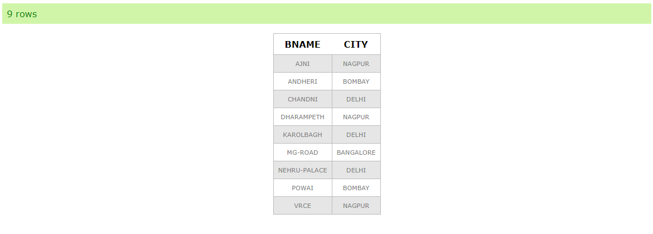
SELECT * FROM BRANCH;

CUSTOMER TABLE
create table CUSTOMER (CNAME VARCHAR(15) PRIMARY KEY,CITY VARCHAR(20) NOT NULL);

INSERT INTO CUSTOMER VALUES('ANIL','CALCUTTA');
INSERT INTO CUSTOMER VALUES('SUNIL','DELHI');
INSERT INTO CUSTOMER VALUES('MEHUL','BARODA');
INSERT INTO CUSTOMER VALUES('MANDAR','PATNA');
INSERT INTO CUSTOMER VALUES('MADHURI','NAGPUR');
INSERT INTO CUSTOMER VALUES('PRAMOD','NAGPUR');
INSERT INTO CUSTOMER VALUES('SANDIP','SURAT');
INSERT INTO CUSTOMER VALUES('SHIVANI','BOMBAY');
INSERT INTO CUSTOMER VALUES('KRANTI','BOMBAY');
INSERT INTO CUSTOMER VALUES('NAREN','BOMBAY');

SELECT * FROM CUSTOMER;

